**Title: Use of Inbuilt functions and relational algebra operation**

**Objective:** To understand the use of inbuilt function and relational algebra with sql query.

Write and execute the following queries using the Relational Algebra on the COMPANY

database schema.

1. Retrieve the names of all employees in department 5 who work more than 10 hours per week on the ‘ProductX’ project.

I/O- select fname,lname from employee where ssn in (select essn from works_on where pno =(select pno from project where pname='ProductX') and hours>10) and dno=5;

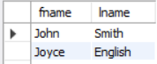

1. List the names of all employees who have a dependent with the same first name as themselves.

I/o- select fname,lname from employee where fname in (select dependent_name from dependent where ssn=essn);

there is no employee with the same name as its dependent

1. Find the names of employees who are directly supervised by ‘Franklin Wong’.

I/o- select concat(fname,lname) from employee where super_ssn=(select ssn from employee where fname="Franklin" and lname="Wong")

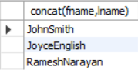

1. Retrieve the names of employees who work on every project.

I/O- select fname,lname from employee where ((select count(*) from project)=(select count(*) from works_on where ssn=essn));

No employee works on every project



1. Retrieve the names of employees who do not work on any project.

I/O- select fname,lname from employee where ((select count(*) from works_on where ssn=essn)=0);

No employee is vacant or not working on any project

1. Retrieve the names and addresses of all employees who work on at least one project located in Houston but whose department has no location in Houston.

I/O- select fname,lname,address from employee where ssn in (select essn from works_on where pno in (select pnumber from project where plocation=”Houston”) and DNO in (select Dnumber from dept_locations where dlocation=”Houston”));

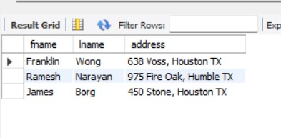

1. Retrieve the last names of all department managers who have no dependents.

I/O- 

select lname from employee where ssn in (select mgr_ssn from department) and ssn not in (select essn from dependent);